Computer Networks and Their Types

A computer network is a system in which multiple computing
devices are interconnected to share data, resources, and services. These
devices communicate using wired or wireless channels, enabling
information exchange and coordination. Networking forms the backbone of
modern digital communication and supports activities like email,
banking, streaming, and remote work.

A network connects devices such as computers,
servers, smartphones, printers, and IoT gadgets. It allows data
transfer, resource sharing, remote access, and centralized management.
Components include nodes, cables, routers, switches, and protocols like
TCP/IP.
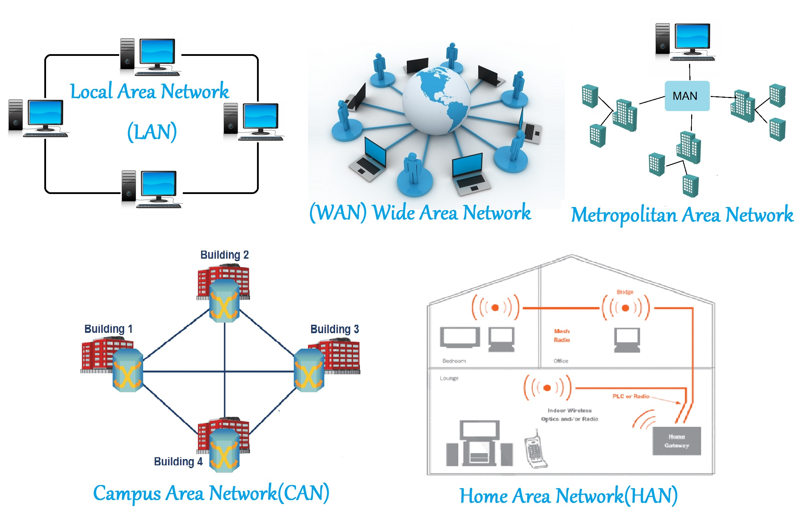
Types of Networks: -
1. Personal Area Network (PAN):- A PAN connects personal
devices within a small area, mainly via wireless methods like Bluetooth.
Examples include smartphone-to-earbud or smartwatch connections.
2. Local Area Network (LAN):- LANs cover small areas like homes, schools,
or offices. They provide high-speed communication using routers,
switches, Ethernet cables, or Wi-Fi.
3. Metropolitan Area Network (MAN):- A MAN spans a city or large campus
and uses high-speed fiber optics. Examples include city-wide cable
networks or university networks.
4. Wide Area Network (WAN) :-WANs cover large geographical areas across
countries or continents. The Internet is the biggest WAN. They
connect LANs and MANs via satellite links and fiber cables.
5. Wireless LAN (WLAN) :- A WLAN uses wireless communication instead of
cables. Wi-Fi networks in homes, malls, and airports are examples.
6. Virtual Private Network (VPN) :_A VPN creates an encrypted tunnel over
public networks. It is used for secure remote access and privacy
protection.
7. Storage Area Network (SAN) :-SANs are special networks used in data
centers to provide fast access to storage devices.

Network Topologies - Bus: Devices share a single communication line. -
Star: Devices connect to a central switch. - Ring: Devices form a closed
loop. - Mesh: Devices interconnect with multiple paths. - Hybrid:
Combination of multiple topologies.

Network Architecture - Client-Server: A central server provides services
to clients. - Peer-to-Peer (P2P): Devices communicate directly without a
central server.
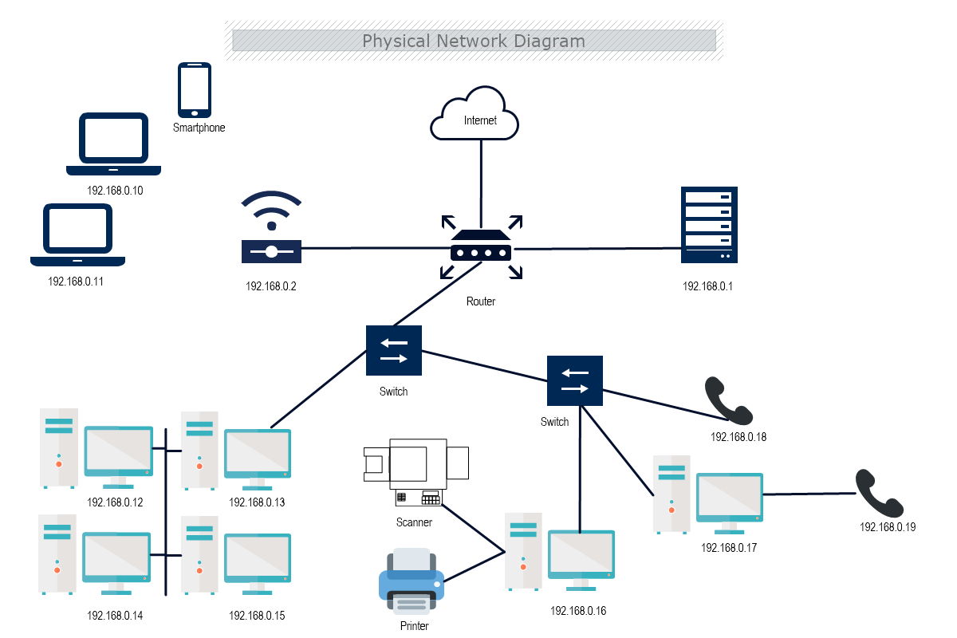
Applications of Networks Networks :-support communication, resource
sharing, e-commerce, education, cloud services, and smart IoT
applications.

